**AL-Khaliq National Innovative School Gudoora**

**Class:-J K G Roll No;- __________ Exam:- FA-5 Sub:- English**

**Q No 1) Write down small alphabets from “a-z”.**



**Q No 2) Write down five Vowels:-**

**Q No 3) Write down two words of the following letter sounds.**

1. A _____________________________ ______________________________________
2. B _____________________________ _______________________________________

**AL-Khaliq National Innovative School Gudoora**

**Class:-J K G Roll No;- __________ Exam:- FA-5 Sub:- Urdu**

**حروف تہیجی ’‘ ا سے ے‘‘ تک لکھیے ۔**

سوال نمبر ۲) تین حرفی الفاظ لکھے۔ (بے جوڑ)

ر + ا + ت = ۔۔۔۔۔۔۔۔۔۔۔۔۔۔۔

و + ر + ق = ۔۔۔۔۔۔۔۔۔۔۔۔۔۔۔

و + ز + ن = ۔۔۔۔۔۔۔۔۔۔۔۔۔۔۔

P

سوال نمبر ۳) درج ذیل حروف تہجی کی آدھی شکلیں لکھیے۔

ب ۔۔۔۔۔۔۔۔۔۔۔۔۔۔۔۔۔۔۔

ت ۔۔۔۔۔۔۔۔۔۔۔۔۔۔۔۔۔۔۔

ث ۔۔۔۔۔۔۔۔۔۔۔۔۔۔۔۔۔۔۔۔۔۔

**AL-Khaliq National Innovative School Gudoora**

**Class:-J K G Roll No;- __________ Exam:- FA-5 Sub:- E V S**

**Q No 1) Write the name of two vegetables:-**

**____________________________ _________________________________**

**Q No 2) Match the animals with their homes:**



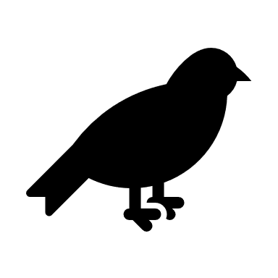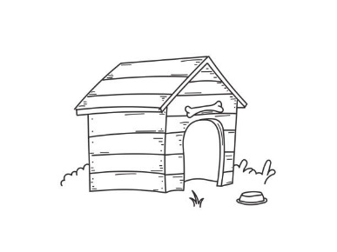

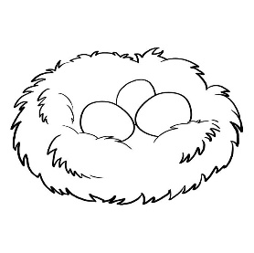

****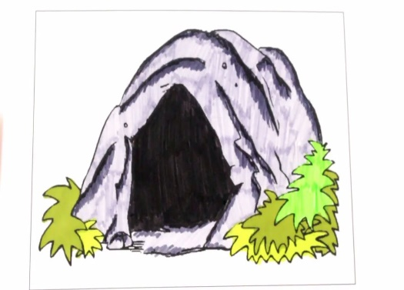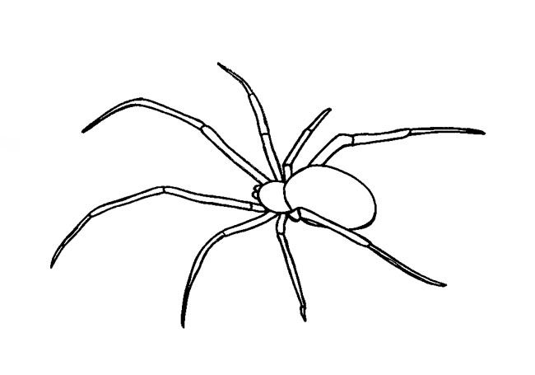

(Please Turn over)

**Q No 3) Match the things that are related to each other:**

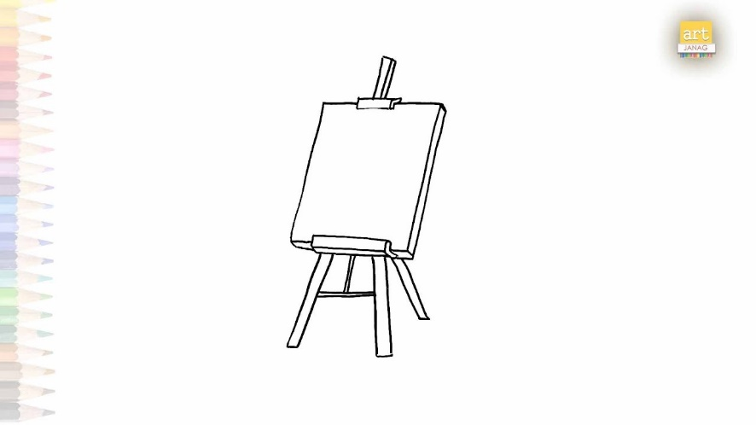

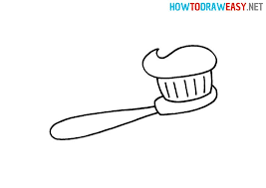

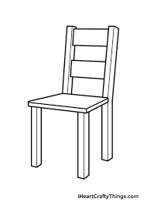



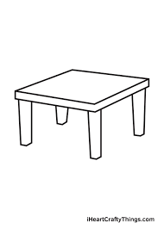

**AL-Khaliq National Innovative School Gudoora**

**Class:-J K G Roll No;- __________ Exam:- FA-5 Sub:- Hindi**

**Q No 1) Write the sawar from** अ to ऋ

Q No 2) Write the missing Akshars:

अ __________________ इ ______________ उ _________________, __________

Please turn over

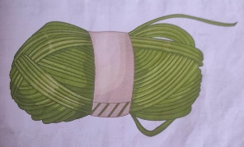Q No 3) Match the Akshar with Pictures.

ऋ

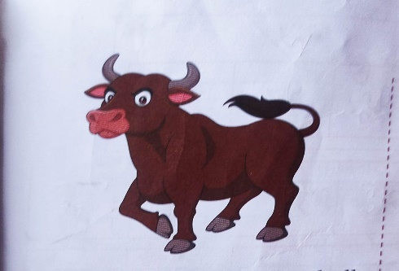

ऊ

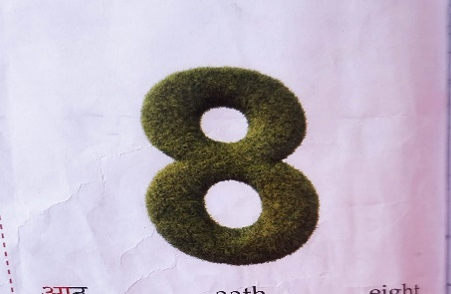

ई

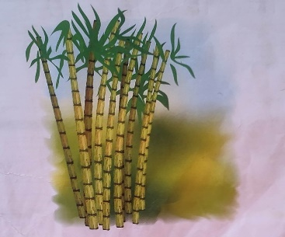

आ

**AL-Khaliq National Innovative School Gudoora**

**Class:-J K G Roll No;- __________ Exam:- FA-5 Sub:- Rhymes (ORAL)**

* Cobbler Cobbler Song
* Counting (1 – 30 )

**AL-Khaliq National Innovative School Gudoora**

**Class:-J K G Exam:- FA-5 Sub:- Communication Skill (ORAL)**

* **Self-Introduction:-**
* I am ________________________
* I am ___________________________ years old.
* I study in _______________________ school.
* I like __________________________.